Utah HAB Guidance Summary
Updated January 2020

Harmful Algal Bloom (HAB) Basics
HABs occur when naturally occurring cyanobacteria, also known as blue-green algae, quickly multiply to high densities and form visible water discoloration, scums, and/or mats. They can occur year round, but are most common in the summer when abundant sunlight and warm, stagnant water combine with high nutrient levels.
They are known as harmful algal blooms since many species of cyanobacteria can produce cyanotoxins that can harm people, pets, livestock, and wildlife. Freshwater cyanotoxins include microcystins, cylindrospermopsin, and anatoxin-a. While no human deaths are known to have been caused by cyanotoxins in the U.S., they have been known to kill pets and wildlife. Exposure to the cells themselves can result in less serious health effects, even when no toxins are present (EPA, 2019).

HAB Identification
HABs can occur in a variety of colors, including bright blue, green, white, brown, and red. More than one color may be present. HABS often (but not always) form scums or mats, and may look like thick paint floating on the water. They may also give off a foul odor. There is no way to determine if a suspected bloom is toxic by looking at it. In addition to causing adverse health effects on their own, cyanobacteria cells counts can provide a proxy measure of cyanotoxins, including those that are measurable and those that are not currently suitable for analysis.
However, it is also easy to mistake growths of green algae or duckweed (both non-harmful) for HABs. Large accumulations of pollen can also look similar. Communicating quantitative measures of cyanobacteria cell counts can help to distinguish between cyanobacteria and green algae and help to communicate HAB magnitude and density. UDOH maintains a webpage with photographs to aid identification (health.utah.gov/enviroepi/appletree/HAB/identify.html).

Public Health Advisories for HABs
UDOH and UDEQ have developed a three tier approach to public health advisories for HABs. These advisories incorporate a variety of measures, but primarily rely on cyanotoxin concentration and cyanobacterial cell density. Typically, the highest level of advisory indicated by any of the measures is recommended to be protective of public health.
Table 1 summarizes the recommended public health advisory tiers. Example advisory signs can be found at habs.utah.gov. Once an advisory is issued, at least two weeks of data indicating that the hazard has passed are recommended before removing the advisory.

Authority
In Utah, the authority to post health advisories and close water bodies lies with the local health departments. As always, UDOH and UDEQ stand ready to support their local partners.
- A local health department may:
  - Prepare, publish, and disseminate information necessary to inform and advise the public concerning the health and wellness of the population, specific hazards, and risk factors. - Utah Code 26A-1-114 (1)(i)(i)
  - Close theatres, schools, and other public places and prohibit gatherings of people when necessary to protect public health. - Utah Code 26A-1-114 (1)(e)

Exposure Routes
People can be exposed to cyanotoxins and cyanobacteria while recreating by incidental ingestion, skin contact, and inhalation of contaminated aerosols. Studies of toxin characteristics and human behavior indicate that oral ingestion is the largest source of recreational exposure to cyanotoxins. Ingestion and skin contact are likely to be important routes of exposure to cyanobacterial cells.

As with most environmental exposures, children are likely to be at greater risk than adults. Children have smaller body mass, spend more time in contact with the water, and typically swallow more water while recreating. Children’s bodies are also still developing and may be more sensitive to the effects of exposure.

Adverse Health Effects
Exposure to HABs can cause a variety of health effects, from relatively mild to potentially serious (EPA, 2019; WHO, 1999; WHO, 2003). Symptoms depend on many factors, including the amount of toxins and/or cyanobacteria, the type of toxin and/or cyanobacteria, and the route and length of exposure. Even in the absence of toxins, there are significant associations between cyanobacterial cells and adverse health effects (EPA, 2019).
Individuals who believe they may be experiencing symptoms of exposure should contact the Utah Poison Control Center: 1-800-222-1222. We ask that information about HAB-related illness in humans and animals be reported to the UPCC. These data are relayed to the CDC and help expand our knowledge about HABs.

Human Symptoms
Inhalation_______________
- Nose irritation
- Sore throat
- Coughing
- Wheezing
- Asthma-like symptoms
- Difficulty breathing
Skin Contact____
- Eye irritation
- Rash
- Hives
- Blisters or sores
Ingestion__________________________
- Tingling sensation
- Muscle cramps
- Dizziness
- Trouble breathing

- Vomiting
- Diarrhea
- Abdominal pain
- Weakness
- Headache

Animal Symptoms
Symptoms include weakness, fatigue, excessive salivation or drooling, staggering, difficulty breathing, vomiting, convulsions, liver damage or failure, and death.

Sampling Procedures
For guidance documents, forms, labels, and additional information, visit deq.utah.gov/water-quality/recreational-health-advisory-guidance#guidance-waterbody-sampling.

Collecting water samples:
- deq.utah.gov/legacy/divisions/water-quality/health-advisory/harmful-algal-blooms/docs/SOP-HAB-Phytoplankton-Samples-2016.pdf

Collecting fish and wildlife samples from mortality events:
- deq.utah.gov/legacy/divisions/water-quality/health-advisory/harmful-algal-blooms/docs/HAB-Carcass-Collection-SOP.pdf

Cyanotoxins and Fish
Cyanotoxins can accumulate in fish in waters with high toxin levels. The highest concentrations are in the organs (particularly the liver) and fat deposits; muscle tissue typically has lower toxin levels. Fish taken from waters with intermittent blooms (as in Utah) are unlikely to have toxin levels in muscle that present a health concern. However, there is considerable uncertainty.
For fish caught in waters during an algal bloom, UDOH and UDEQ recommend discarding the guts and skin, eating only the fillets, and rinsing them with clean water (e.g., tap or bottled).

Cyanotoxins, Crop Irrigation, and Livestock Watering
Contact the Utah Department of Agriculture for guidance: ag.utah.gov; (801) 538-7100.

Cyanotoxins and Secondary Water Use
Very little information is available. Contact UDEQ, UDOH, and the secondary water provider for consultation.

Observed / Potential Blooms
Local health departments, UDEQ, UDOH, and other HAB response agencies regularly receive information that suggests an unknown bloom may exist or an existing bloom may become more severe. Such indicators include visual reports, reports of animal or human illness potentially associated with an unknown bloom, and toxins or cyanobacteria cell counts below Utah recreational health advisory thresholds. Frequently this information arrives well before data upon which to base an advisory decision can be collected or analyzed.
In order to inform both local health departments and the public of the latest recreational health dangers of a given water body, a pre-advisory tier has been added to the Utah HAB advisory approach. The Observed/Potential Blooms tier is not a formal advisory level, but instead indicates that increased monitoring and surveillance are strongly recommended and water body users should be informed depending on specifics of the event and water body.

HAB Contacts
Report a Bloom: UDEQ 24-hour Spill Hotline: (801) 536-4123

Immediate Health Concerns:
Utah Poison Control Center: 1-800-222-1222
Human & Animal Illness Info:

UDEQ: (801) 536-4300
habs.utah.gov
Kate Fickas kfickas@utah.gov
Ben Holcomb bholcomb@utah.gov

UDOH: (801) 538-6191
health.utah.gov/enviroepi/appletree/HAB
Nathan LaCross nlacross@utah.gov
Alejandra Maldonado: alejandramaldonado@utah.gov

Table 1: UDOH/UDEQ Recommended HAB Advisory Thresholds
Observed / Potential Bloom |  | Warning Advisory | Danger Advisory
This is not a formal advisory level. Rather, these are indicators that a bloom may exist or may become more severe. Increased monitoring and surveillance are strongly recommended. Indicators may include:  - Visual reports  - Reports of animal or human illness  - Detection of cyanotoxins below thresholds  - Detectable levels should be defined using appropriate QA/QC procedures  Consider cautioning users of the waterbody depending on specifics of the event and waterbody. | Cyanobacterial Cell Density (cells/mL) ^{1,2,3} | 5,000 - 100,000  Human symptoms have been reported within this range³. An advisory should be issued at 100,000 cells/mL. Below 100,000 cells/mL, take into account other contextual information and consider issuing an advisory. | 10,000,000
 | Microcystins (µg/L) ^{1,2} | 8 | 2,000
 | Cylindrospermopsin  (µg/L) ³ | 15 *
 | Anatoxin-a (µg/L) ^{3,4,5} | 15 | 90
 | Health Risks ^{1,2,3} | Potential for long-term illness | Potential for acute poisoning
 |  | Short-term effects (e.g., skin and eye irritation, nausea, vomiting, diarrhea) | Potential for long-term illness
 |  |  | Short-term effects (e.g., skin and eye irritation, nausea, vomiting, diarrhea)
 | Recommended Actions | Issue WARNING advisory | Issue DANGER advisory
 |  | Post WARNING signs | Post DANGER signs
 |  |  | Consider CLOSURE
 |  | Sampling recommended at least weekly | Sampling recommended at least weekly
Guidance sources
¹ WHO, 1999. Toxic cyanobacteria in water.
² WHO, 2003. Guidelines for safe recreational water environments, Volume 1, Chapter 8: Algae and cyanobacteria in fresh water.
³ EPA, 2019. Recommended human health recreational ambient water quality criteria or swimming advisories for microcystins and cylindrospermopsin.
⁴ OHA, 2019. Oregon Health Authority. Recreational use public advisory guidelines: cyanobacterial blooms in freshwater bodies.
⁵ CWQMC, 2016. California Water Quality Monitoring Council. Cyanobacteria guidance for recreational and related water uses (2016 update).
* Data are sparse on where cylindrospermopsin advisory break points should be. Consult with UDEQ and UDOH as needed on this issue.

Figure 1: Health advisory flow chart
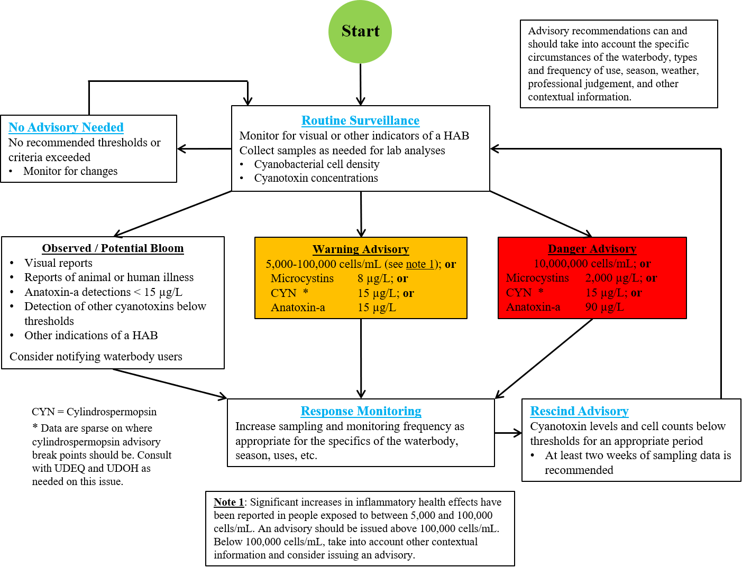

References
CWQMC, 2016. California Water Quality Monitoring Council. Cyanobacteria guidance for recreational and related water uses (2016 update). Available online at: mywaterquality.ca.gov/habs/resources/habs_response.html

EPA, 2019. U.S. Environmental Protection Agency. Recommended human health recreational ambient water quality criteria or swimming advisories for microcystins and cylindrospermopsin. Available online at: www.epa.gov/wqc/recommended-human-health-recreational-ambient-water-quality-criteria-or-swimming-advisories

OHA, 2019. Oregon Health Authority. Recreational use public advisory guidelines: cyanobacterial blooms in freshwater bodies. Available online at: www.oregon.gov/oha/PH/HEALTHYENVIRONMENTS/RECREATION/HARMFULALGAEBLOOMS/Pages/resources_for_samplers.aspx

WHO, 1999. World Health Organization. Toxic cyanobacteria in water. Available online at: www.who.int/water_sanitation_health/publications/toxicyanobact/en

WHO, 2003. World Health Organization. Guidelines for safe recreational water environments, Volume 1, Chapter 8: Algae and cyanobacteria in fresh water. Available online at: www.who.int/water_sanitation_health/publications/srwe1/en

